Check Total for the Pipe Hardening Methodologies for the Carbon Constraint Future

The following “Check Total” ranges provide a “sanity check” for the level of the increases in the pipes. It is not an alternate hardening method.

Total Interface Pipe Expansions for Each Hardening Methodology Compared to the "Check Total" (MW)
Sensitivity | RHC | Johnson | NGO | Average | Check Total Range
OL75 | 14,205 | 12,034 | 17,657 | 14,633 | 29,594 to 42,218 MW
OL25 | 43,370 | 26,898 | 37,511 | 35,926 | 50,830 to 68,762 MW

The Check Total relies on the net energy exports from the NEEM model from the MISO/MAPP and SPP/Nebraska/Entergy regions (i.e. the “Western Super Regions”) to the rest of the Eastern Interconnect.

Check Total Details

As might be expected, a large amount of wind is added in the Carbon Constraint Future and the associated OL75 and OL25 “pipe expansion” sensitivities. The NEEM summary results shows that 252,000 and 266,000 MW of wind was added in the MISO/MAPP and SPP/Nebraska/Entergy regions (i.e. the “Western Super Regions”) in the Carbon Constraint OL75 and OL25 “pipe expansion” sensitivities, respectively. Not surprisingly, these large amounts of wind result in significant energy exports from the Western Super Region to the rest of the Eastern Interconnect (which for ease of discussion will subsequently be referred to as the “Eastern Super Regions”). These energy exports (221,170,000 MWh and 314,180,000 MWh for OL75 and OL25, respectively) can be used to estimate the total amount of transfer capability needed across the transmission pipe interface between the Western Super Regions and the Eastern Super Regions. This interface includes the pipes that cross from west to east across the dashed green line shown below and in the subsequent table.

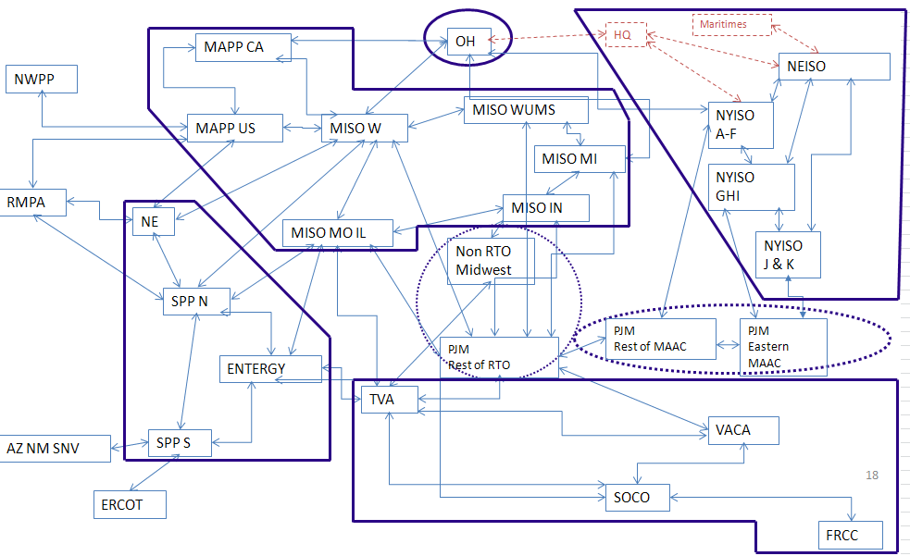

Transmission Pipe Interface between the Western Super Regions and the Eastern Super Regions
From Region | To Region | Maximum Baseline Transfer
Entergy | SOCO | 2,000
Entergy | TVA | 2,100
MISO MO IL | TVA | 4,000
MISO MO IL | PJM ROR | 1,212
MISO W | PJM ROR | 773
MISO WUMS | PJM ROR | 1,600
MISO IN | Non RTO Midwest | 4,800
MISO IN | PJM ROR | 992
MISO MI | PJM ROR | 1,424
MAPP CA | IESO | 330
MISO W | IESO | 90
MISO MI | IESO | 1,580
 |  | 20,901

Capacity Factors for Actual Transmission Interfaces/Pipes (Whose Expansion Was Economically Justified)

Starting with exports from the Western Super Regions, a key question for determining the total west-east interface transfer capability (and associated pipe sizes) is the appropriate capacity factor to use for the pipes. Calculating capacity factors for transmission is new concept and consequently there is no yardstick for transmission line capacity factors, like there is for generators.

To get a sense of the capacity factor level one might expect on transmission, when economic transmission upgrades are made, the American Transmission Company (ATC) looked at two MISO_WUMS transmission interfaces that were expanded based on economics. These include the MISO_WUMS Southwest Interface (after the Paddock-Rockdale line) and the MISO_WUMS Western Interface (after the Arrowhead-Weston line). After these line additions, the capacity factor on the MISO_WUMS Southwest Interface and the MISO_WUMS Western Interface were both approximately 47%.

Tyler Ruthven said that the Hydro Quebec to New York transmission line, that is also economically justified, has a 40% capacity factor. He also noted that other existing transmission lines in his area have capacity factors in the range of 20 to 40%.

This information suggests that for expanding pipes based on economics, pipe capacity factors in the range of 40 to 50% would be reasonable.

Also, as previously noted, it is the large amount of wind power that results in the significant exports from the Western Super Regions to the Eastern Super Regions. This wind has average capacity factors in the range of 40%, which also supports the idea of using pipe capacity factors in the range of 40% for calculating the total west-east interface transfer capability.

The tables below give the Check Total calculations for the OL75 and OL25 sensitivities:

Carbon Constraint OL75 Transfer Capability Estimate to the Eastern Super Regions from the
Western Super Regions
Western Super Region Net Exports in 2030 (MWh) | 221,170,000
Total MW Transfers to the East Assuming a 40% Pipe Capacity Factor | 63,119*
Maximum Baseline Transmission Transfer | -20,901
Difference--Total Incremental Transfer Capability Across Interface (MW) | 42,218
Total MW Transfers to the East Assuming a 50% Pipe Capacity Factor | 50,495
Maximum Baseline Transmission Transfer | -20,901
Difference--Total Incremental Transfer Capability Across Interface (MW) | 29,594

*The calculation is 221,170,000/(8760*0.4) = 63,119 MW.

Carbon Constraint OL25 Transfer Capability Estimate to the Eastern Super Regions from the Western Super Regions
Western Super Region Net Exports in 2030 (MWh) |  | 314,180,000
Total Transfers to the East Assuming a 40% Pipe Capacity Factor (MW)* |  | 89,663
Maximum Baseline Transmission Transfer (MW) |  | -20,901
Difference--Total Incremental Transfer Capability Across Interface (MW) |  | 68,762
Total Transfers to the East Assuming a 50% Pipe Capacity Factor (MW) |  | 71,731
Maximum Baseline Transmission Transfer (MW) |  | -20,901
Difference--Total Incremental Transfer Capability Across Interface (MW) |  | 50,830

*The calculation is 314,180,00/(8760*0.4) = 89,663 MW.

Assuming the average of the 3 hardening methodologies (based on the OL75 sensitivity) is selected for expanding the pipes, the west-east transfer capability comparable to the Check Totals above would only be 14,633 MW.

Pipe Expansions-Avg of 3 Hardening Methods-OL75 | MW
MISO W to PJM ROR | 12,420
ENT to SOCO | 1,952
MISO IN to PJM ROR | 261
Incremental Interface Expansion | 14,633

Assuming the average of the 3 hardening methodologies (based on the OL25 sensitivity) is selected for expanding the pipes, the west-east transfer capability comparable to the Check Totals above would be 35,926 MW.

Pipe Expansions-Avg of 3 Hardening Method-OL25 | MW
MISO W to PJM ROR | 31,421
ENT to SOCO | 4,505
Incremental Interface Expansion | 35,926

